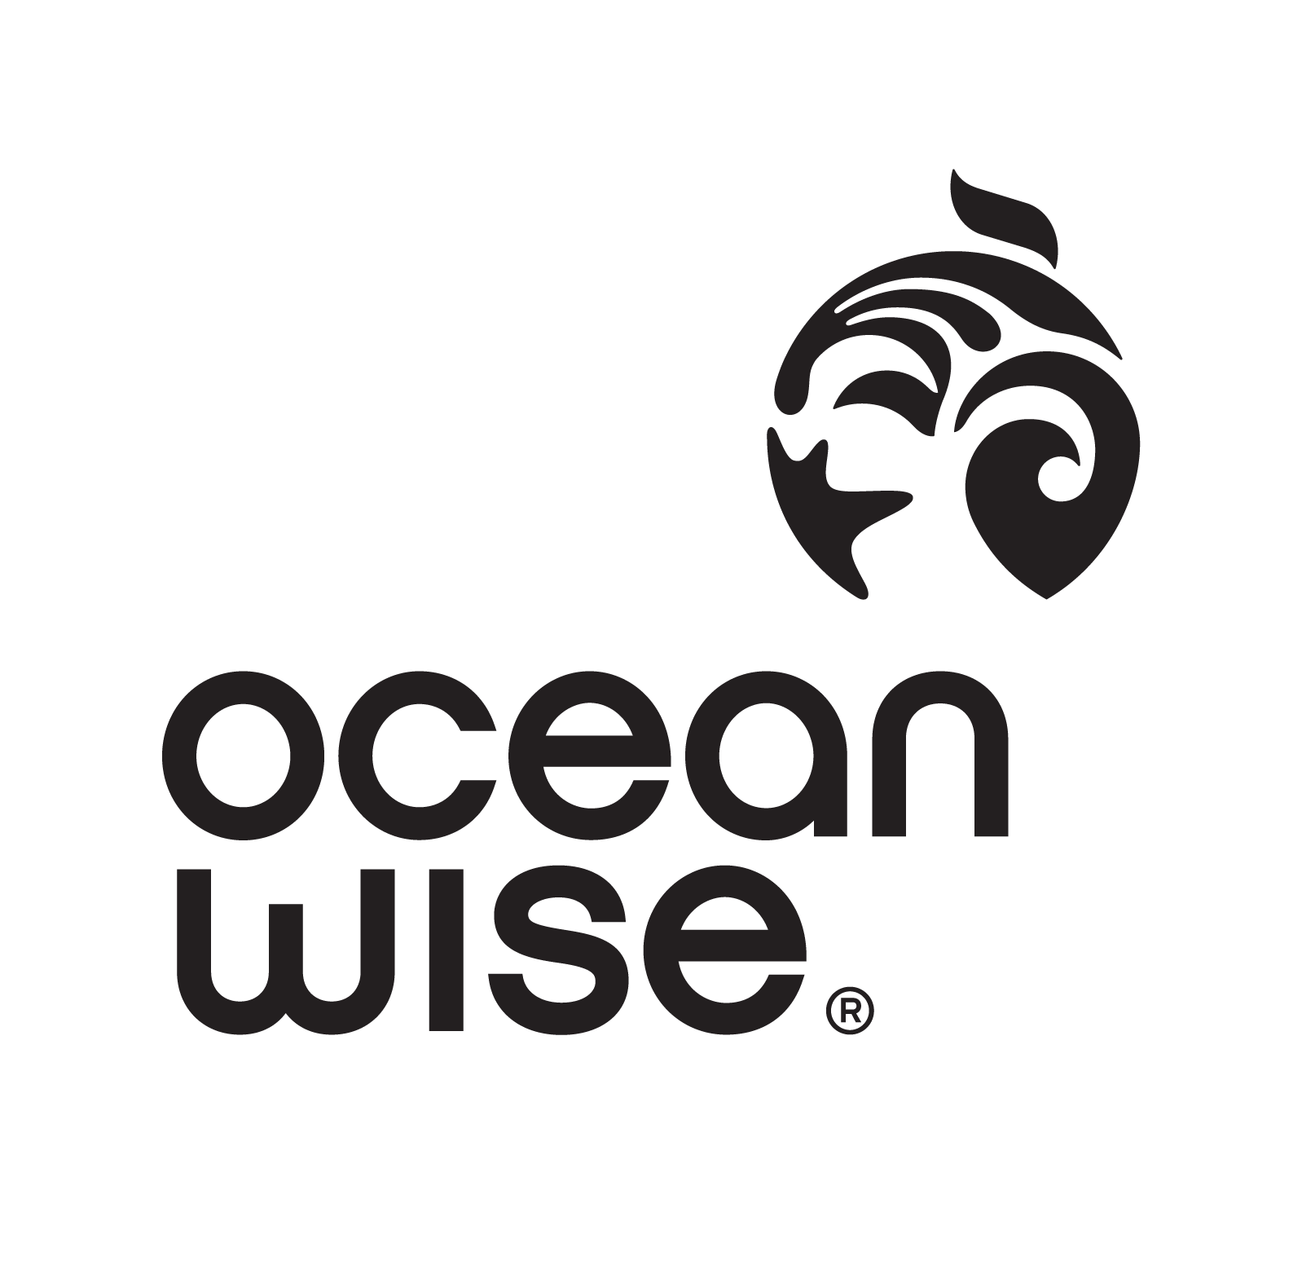
MEETING MINUTES – YOUTH STEERING COMMITTEE
Location: Vancouver Aquarium
V6G 3E2
Date: November 25 2018
Time: 3pm – 5pm

Attendance: Quinton, Tate, Pavel, Annabel, Ellie, Alex, Giulio, Hannah, Natasha, Risa, Hailey C., Sonja

Virtual: Kaelin, Matias

Agenda Items

1 – Commitment
- Once per month in person, video calls 1-2x per month
- Request: meetings not at the Aquarium (out of the way)
- For virtual calls, we will use Google Hangout – Hailey R. will send out meeting invites a few days prior to scheduled meeting

2 – Program Scope
- What are the goals for the program? Where do we see ourselves going?
- Ideas: some places don’t have recycling cans or systems in place to recycle, spread awareness of climate change and microplastics, a lot of people care but don’t know how they are affecting the environment, some schools don’t have environment clubs
- What do we want to do? → show people that they are actually connected to the oceans, similar to Salish Sea Science Program
- Our role: help people plan things, we are youth leaders that help mentor people

3 – Program Contributors
- Are there any organizations that we can reach out to?
- Ideas: Quinton – board member of temple, Pavel – Green Team at school, Grouse Mountain manager (camp theme of sustainability), Natasha – member of environment club, Annabel – collaborate with clubs at school (ex. Interact Club), maybe we could organize a green conference for youth

4 – Goals and Ideas
- Volunteers – get the word out to schools, find volunteers to help us with the program (it would be volunteers that our youth mentor – want to keep the “board” small and intimate)
- Contact organizations (ex. Girl Guides, Boys and Girls Club, community centres) and assess if they would be interested in doing programming with us
  - Ex. We offer to run a free 30-60min session on the oceans
  - Example contacts – Girl Guides, Boys and Girls Club, Boy Scouts, 4 Cats, YMCA, community centres/programs (sports teams – bring environmental game)
- Advertise our small group to outside people
- Conference – plan an event with programming around it
- Guest speakers
- Make presentations on our experiences and share with our networks (ex. Giulio with Hornby trip and return to Italy, share programs with other international students, share Ocean Wise message with international students)
- Program = youth led → youth need to see that people like us are capable of change
- Partner with bigger schools, have open houses (ex. UBC – encourage them to help, they can be our mentors, Science World, SFU, science 10 classes with trips to aquarium)

5 – Roles
- Marketing – responsible for communication (social media), graphics, advertising
  - Tate, Pavel, Giulio, Alex, Kaelin
- Development – responsible for program pitch, organization, scheduling, tracking attendance and contacts, etc.
  - Quinton, Natasha, Ellie, Annabel
- Outreach – responsible for finding and reaching out to potential partners, schools, organizations, etc.
  - Sanja, Ellie, Kaelin, Hailey C.
- Website – design and maintenance
  - Matias
- Application – program development and scheduling
  - Quinton, Rise, Hailey C, Hannah

6 – Mission Statement
- Buzzwords: empowering, ocean, education, awareness, change, youth-led, fun, engaging, mentorship
- What are we doing? → leaders, good examples of leaders, influence the change, mentors, consulting on what people would like – what info do they want to improve their programming?
- Long term goal: we create an outline for other groups to use
- Short term goal: spread the word and awareness on the state of our oceans

Action Items

1 – Next Meeting
- Answer Doodle Poll: https://doodle.com/poll/q39p8ma5dh8hi9ay
- Meeting Room: if not the Aquarium, where will we meet that has access to a computer with video/microphone to call in virtual team members?

2 – Network and Pitch
- Find some organizations and schools that we think would be interested in collaborating/using our programming
- Create a base model of the program – what is it, how do they benefit, what is in it for them?

3 – Team Meetings
- Set up meetings with your department to discuss department goals, and how you are going to get there (make a plan), build a familiarity with your team – are there different responsibilities within the team? Different roles?
- At our next meeting, we will present your department organization to the rest of the teams

4 – Name and Mission
- Please brainstorm a few potential names for our “club” and bring them to the next meeting
- Mission statement: take our ideas and formulate a realistic statement. Do we want a mission and a vision?
- What exactly are we doing here? We need to nail this down so we can start creating a pitch.

